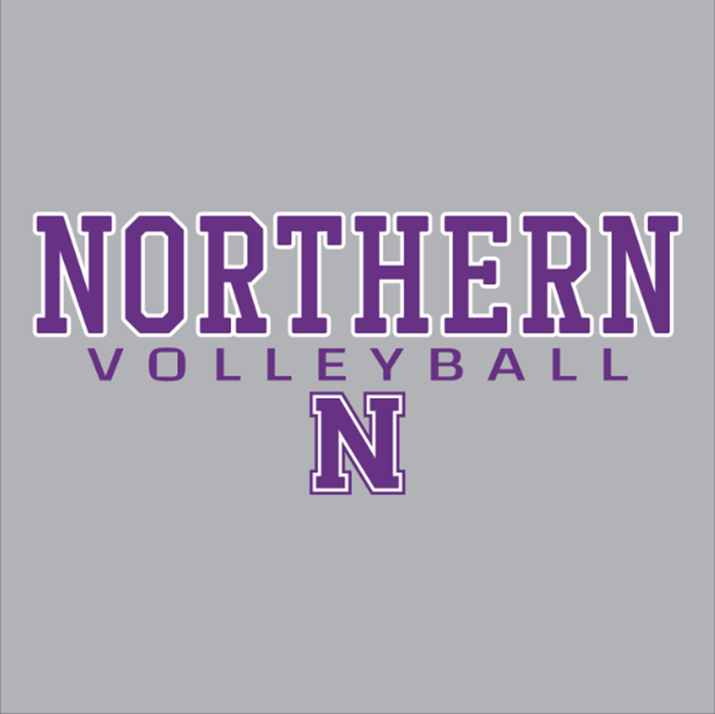

**Player and Parent Handbook**

**2022 Season**

**Coaching philosophy**:

I believe that high school volleyball can have a significant positive impact on the work ethic, leadership, teamwork, competitive spirit, and sport-specific skills of each student athlete. This program will focus on what it means to be a part of team and maintain good sportsmanship, while competing at a high level. I believe that a sports program can only be successful if the athletes are strong in the fundamentals of the sport and are taught to anticipate and make adjustments on their own. I will work hard to provide my athletes with the best training and support I can to help them reach both their individual and team potential. My goal is that the boys who pass through this program will compete at a high level and, above all, become life-long lovers of volleyball and who use that love to make a difference in their community.

**Mission Statement**: The boys volleyball program will focus on developing players both as athletes and as young men. We will focus on the personal and athletic development of our student athletes. Our program will include character development and volleyball skills training to help each player reach their maximum potential.

**PROGRAM STAFF:**

**Head Coach, Joe Bodisch** – jbodisch3@gmail.com

* 1st year – Northern Boys Volleyball Varsity Head Coach (6th year with the program)
* Graduate of Penn State University with a degree in Physics
* Boys JV Head Coach, Northern High School 2019-2021
* Program Director, Freeze Volleyball Club LLC
* Played volleyball for 4 years at Northern
* Biochemistry Instrument Administrator, Eurofins Lancaster Labs since 2016

**Junior Varsity Head Coach, Andrew Smith**

* 1st year – Northern Boys Volleyball JV Coach
* Graduate of Penn State with University with a Degree in Education and Public Policy
* Played volleyball for 4 years at Northern
* Team Manager, Penn State University Women’s Volleyball for 3 years

**Volunteer Assistant Coach, Travis Moyer**

* 5th year – Northern Boys Volleyball Coach
* Graduate of Messiah College with a degree in Mathematics Education
* Played volleyball for 4 years at Messiah College
* Boys JV Head Coach, Carlisle High School 2016
* Math Teacher, Northern High School

**Volunteer Assistant Coach, Toby Brubaker**

* 1st year – Volunteer Assistant Coach
* Played volleyball for 4 years at Northern
* Electrician, Secco Electric

**Athletic Trainer – Mr. Donnie Russell**

* drussell@northernyork.org
* 432-8691, x2016

**Athletic Director – Ms. Angie Gaido**

* agaido@northernyork.org
* 432-8691, x2014

**PRACTICE/TEAM EVENT ATTENDANCE**

**General Expectations:**

* It is expected that Northern Boys Volleyball players attend all scheduled practices and matches and team events, unless they notify a coach **in writing OR through the Remind APP at least 1 day prior** to the practice, game or team event.
* The players should arrive to the school 10 minutes prior to the start of practice. This will allow time to get the nets set up and start practice on time. The athlete will be considered late if he is not on the court by the scheduled time.
* If athletes need to see the trainer for an extended amount of time, such as getting taped, receiving therapy, heating/icing, then they should arrive at least 20 minutes prior to the start of practice.
* Amount of playing time will be reduced as a result of unexcused tardies, excused absences, and unexcused absences at the discretion of the coach.

**Practice/Team Event Tardies:**

Excused Tardies are:

* Receiving academic help from a teacher or speaking to a counselor during practice...arrive as soon as possible afterwards with an official Northern High School PASS signed by the teacher or guidance counselor.
* **Necessary doctors’ appointments...please try to schedule around practice times. Players will need to provide a doctor’s note to their coach upon their return.**
* Returning from a college visit

Unexcused Tardies include but are not limited to the following:

* Talking to my friends in the hall and lost track of time.
* NHS detention or suspension.
* My parents were running late.
* In the training room. You should allow enough time to see the trainer so that you are not late to practice.

**Students who are involved with other Northern High School extracurriculars must let Coach Bodisch know in advance if there are schedule conflicts. The amount of playing time *may* be reduced at the discretion of the coach.**

**Practice/Team Event Absences:**

Excused Absences are:

* A legal school absence during the day of participation...illness, college visit, etc.
* Necessary doctors’ appointments...please try to schedule around practice times.
* Family emergencies...sudden illness, car accident, death in the family.
* Attended a full day of school, but went home sick at the end of the day… player/parent must call, email or send a remind to the coach.
* Prescheduled school sponsored activities (i.e. DECA, FBLA, Jazz Band, play, field trip, musical activities).

Unexcused Absences – Please Refer to the Northern Athletice Code of Conduct

* Players who arrive to school late: Athletes must be in school by 9:00 AM in order to participate in practice or a volleyball match that day, unless a written excuse/explanation from a doctor, dentist or college that you visited is provided.
* An athlete cannot compete in Saturday tournaments/practices if he is not in school on Friday, unless he has a note from a doctor or college. This is a school policy.

**Policy for missing practices or team events (Unexcused):**

* If a player misses 1 practice/event, then he will not be able to play in the 1st set of the next match.
* If a player misses 2 practices/events, then he will not be able to play in the 1st or 2nd set of the next match.
* If a player misses 3 practices/events, then he will not be able to play in the first 3 sets of the next match.
* If a player misses 4 practices/events, then he will not be able to play in 1 entire match.
* If a player misses 5 practices/events, then he will not be able to play in 1 entire match and the 1st set of the next.

**In- School Suspension - athletes cannot practice or participate in contests during periods of in-school suspension.**

**Academic Eligibility:** Students must demonstrate academic eligibility in order to participate in interscholastic athletics. The student must be passing four and one-quarter (4.25) credits on a weekly cumulative basis. If students do not meet this standard they become ineligible for the following week (Monday through Saturday). During that week, the ineligible player may not attend any team-related activities.

**PRACTICE AND MATCH SCHEDULE**

* Practices will be after school from 3:00 to 5:00 at the high school gym. In addition, varsity will have practices on Saturdays from 9:00 to 11:00. Practice times may be changed this year because the middle school gym has a leak and girls middle school volleyball needs to use the high school gym. On days that middle school volleyball has a match, practices will start after their match is over, around 6:00, and run for 2 hours.
* Practice is closed to parents and spectators. Please respect this time for the coaching staff to teach and prepare the team.
* Home matches will start at 5:00 for JV, with varsity playing immediately after, unless the middle school team has a match. If that is the case, our match will begin immediately after completion of the middle school match.
* Please see the Arbiterlive website for team game schedules. [arbiterlive.com/Teams?entityId=16473](http://arbiterlive.com/Teams?entityId=16473). Any date or time changes will be sent out via a REMIND notification.
* Practice and game schedules are subject to change throughout the season.
* Cancellation of Practice – If practice is canceled at the last minute, an announcement will be made during school. If this would happen, the players should plan to go home on the bus or via mode of normal transportation used daily. A REMIND notice will be sent via text to players and parents.

**Game Day Expectations:**

***All Games*** – During the JV Match: Varsity will shag balls during warm-ups and keep stats or line judge as needed while the JV team is playing. During the Varsity Match: JV will shag balls during warm-ups and keep stats or line judge as needed while the Varsity team is playing.

All players must stay and sit as a team for both matches (JV and Varsity) to cheer for their teammates. Players may not be on their cell phones during the matches. Please refer to the Northern Code of Conduct.

***Home Matches*** –All players need to arrive by 4:15. Varisty will put up the game net and JV players will be responsible for taking the net down at the completion of the varsity match. Players may not leave the gym until everything is taken care of and they check in with a coach.

***Away Matches*** – All players need to arrive 15 minutes before the bus departs. Players must return home on the team bus from our away matches. However, if riding home from an away match with your parent or guardian is necessary, you must hand in a signed note from your parent before the bus leaves Northern. A volleyball player may not ride home from an away match with someone else’s parents/guardians. Please refer to the Northern Code of Conduct.

** If you are late for an away game, the bus will leave on time without you. You cannot play in a game if you do not ride the bus to the game, unless you have been granted permission by the coach or the AD prior to the day of the match.

***Player Attire on Days of Away Matches*** – Players will dress up with a shirt, tie and dress pants. School Dress Code applies. No blue jeans, sweatshirts or athletic gear should be worn. Players are not required to wear what they wore to the away match for the ride home. Players should have athletic wear such as sweatpants, warm-up pants, shorts, and a t-shirt to change into (nothing with holes and no pajama pants).

***Player Attire on Days of Home Matches*** *–* The team leaders will choose whether the team will wear their team shirts or their warm-ups on the days of home matches throughout the season.

**Consequences for not following the team dress code on game days are at the discretion of the coach.

***Picking Up Athletes At School After Away Matches*** – Parents, please plan to be parked and waiting in the school parking lot when the bus arrives back at NHS, so that the athletes and coaching staff do not have to wait for you to arrive. Parents will be contacted when they are about 15-25 minutes away from Northern so that you can properly time your arrival.

**COMMUNICATION**

Frequent, open communication between the coaching staff, players, and parents/guardians is very important. Each player and parent are required to sign up for the REMIND text. Please be sure to check your email consistently for any new booster or team information emails. If a player has concerns about anything related to playing time or team issues, they should speak to their head coach first.

Concerns that are NOT appropriate for parents to discuss with the coaches.

* Playing time.
* Team strategy.

Appropriate concerns for parents to address with the coach:

* The mental and physical treatment of the athlete.
* What the athlete needs to do to improve.
* Aspects of the athlete’s behavior.
* Concerns about the program philosophy or expectations.

**TEAM LEADER(S)**

Volleyball Team Leaders will be selected by the coaching staff. This is neither a popularity contest nor a matter of who is the best volleyball player. Team Leaders will be selected based on players being:

* **A GOOD STUDENT**…one who consistently maintains his academic eligibility.
* **COMMITTED**....to volleyball by virtue of having an excellent attendance record.
* **PASSIONATE / ENTHUSIASTIC**…about volleyball and being around his teammates.
* **POSITIVE**....always uplifting, quick to compliment others and slow to criticize.
* **TEAM ORIENTED (SELFLESS)…**willing to put the needs of the team ahead of his own.
* **TRUSTWORTHY**…supportive of the coaching staff, able to handle sensitive information properly.
* **A GOOD LISTENER**…always completely focused on what is being said by others.
* **RESPECTFUL**...of the differences in others…treats everyone with respect, regardless of their circumstances.
* **HELPFUL**...often extending a helping hand…always looking for ways to help others on the team.
* **MATURE**…conducts himself as a young adult at all times….a role model for others.
* **RESPONSIBLE**…when given an assignment, he carries it out without being reminded.
* **A HARD WORKER**…focused on completing all training as specifically requested by the coaches.

**NORTHERN HIGH BOYS VOLLEYBALL HANDBOOK SIGNATURE FORM:**

Please return this page only to Coach Bodisch by Wednesday, March 16

We have read the Volleyball Handbook. We understand the guidelines, rules and philosophy of the volleyball program. We understand that our signature does not signify agreement with all areas, but does signify that we will do all we are capable of to help follow and enforce these expectations. Therefore, we are attaching our signatures below on this page:

Player’s Name___________________________________________

Player’s Signature________________________________________

Date______________

Parent/Guardian Signature_____________________________________________

Date______________

Parent/Guardian Signature_____________________________________________

Date______________

Parent/Guardian email address__________________________________________

Parent/Guardian email address__________________________________________